**VGU010**

**10-Channel, Modular, Variable/ Fixed Gain Unit**

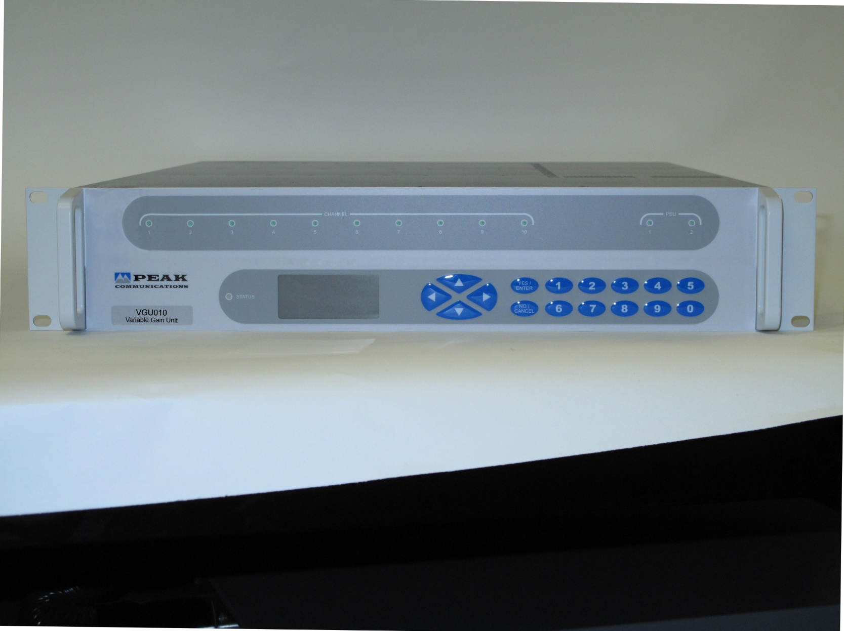

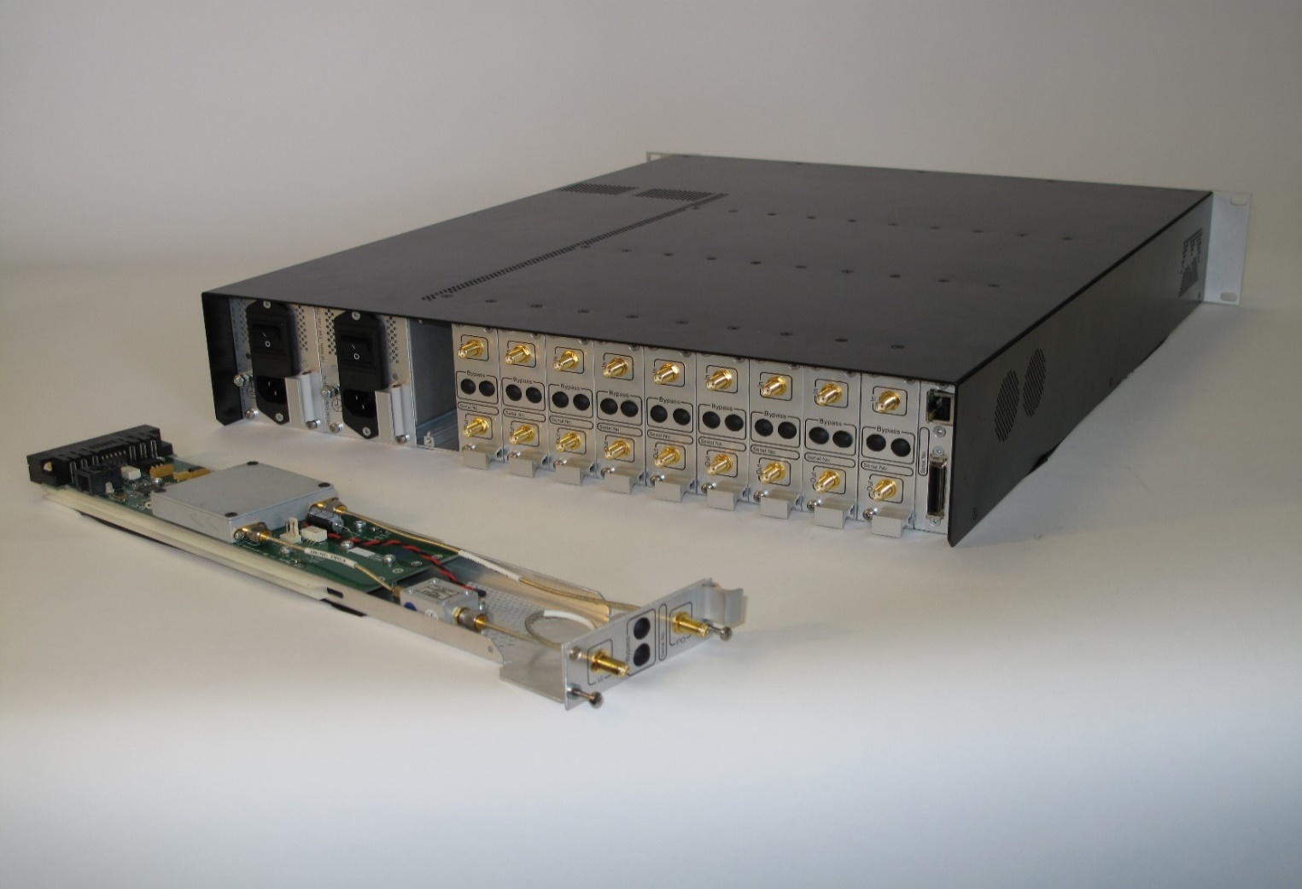

The **VGU010** system provides fixed gain &/ or attenuation control of IF, L-Band & SHF based signals, which can be used for balancing during commissioning to overcome differences in cross-site cable losses, as well as providing a useful facility for earth station operators to adjust the gain of uplink/ downlink chains remotely. SHF units can be used for coverage and capacity layer testing for 5G networks.

The **VGU010** is a multi-channel variable gain unit which can accommodate up to 10off **MVG00x** variable gain/ attenuation channels or **MFG00x** fixed gainchannels, each of which are modular, ‘hot-swappable’ and can be inserted/ replaced in the **VGU010** unit from the rear without the need to remove power or disturb the other channels in any way.

The **MVG00x/ MFG00x** modules are available for use at either IF (70MHz ±18MHz/ 140MHz ±36MHz), L-Band (950-2150MHz) & SHF (for example 3.4-3.8GHz for 5G networks) and can be positioned in either the uplink or downlink chain. Each module houses a single IF, L-Band or SHF channel and can be fitted with fail-safe switching option.

The **VGU010** chassis is mains powered with dual (redundant), modular, hot-swappable power supplies, as standard.

***Peak Features***

Hill Flexible; modular, ‘hot-swappable’, expandable solution

Hill Active & passive slope compensation options

Hill Full remote control of **MVG00x** signal variable attenuation, 0-30dB range with fine 0.1dB adjustment control

Full alarm monitoring



Hill Ability to support integral passive splitter/ combiner modules

Hill Redundant power supplies with dual mains input

***VGU010 chassis – Typical Specification***

Number of channels 1 to 10 (each MVG00x/ MFG00x denotes a single channel)

***MVG00x – Variable Attenuation Module***

***Typical RF Performance***

**MVG001;** 50-200MHz

**MVG002;** 950-2150MHz

**MVG005;** 3.4-3.8GHz

**MVG006;** 3.4-4.2GHz

**MVG007;** 10.7-12.75GHz

Connector type SMA (f), 50Ohm

DC & 10MHz pass Allows DC & 10MHz signals on the L-Band input

(Option 4) to be passed through to the output

1 dB GCP Input 0dBm, output +1dBm

Return loss* 14dB nom (input and output)

Insertion loss* 1dB nom at min attenuation

Option 6a; Gain of 15dB nom, at min attenuation

Option 6b; Gain of 27dB nom, at min attenuation

Note: For other gain options please contact the factory

Attenuation control 0-30dB, stepped 0.1dB

Gain stability ±0.5dB from 0 to 400C  
±0.1dB per week (constant temp)

Gain flatness* ±1.5dB (MVG002 & 5 over full band)

±0.5dB (across any 36MHz in band)

±0.5dB over IF band (MVG001)

Bypass (Option 5) Fail-safe switching to external user selectable pad

Bypass connection SMA (f), 50Ohm (2 connections per channel)

Bypass insertion loss 1dB (plus external pad fixed attenuation value)

* The addition of options 4, 5 & 6 may modify the performance (for details please contact the factory).

***MFG00x – Fixed Gain Module***

***Typical RF Performance***

Note: Performance as above, unless stated below;

**MFG001;** 50-200MHz

**MFG002;** 950-1450MHz

**MFG003;** 950-1750MHz

**MFG004;** 950-2150MHz

**MFG005;** 3.4-3.8GHz

**MFG006;** 3.4-4.2GHz

**MFG007;** 10.7-12.75GHz

RF input power -10dBm max (no load, no damage)

TOIP +25dBm

1dB output GCP +13dBm

Return loss* 16dB nom (input and output)

Gain* 20dB nom

Option 7a; 30dB nom

Option 7b; 40dB nom

Note: For other gain options please contact the factory

Gain flatness* ±0.25dB (bandwidths ≤500MHz)

±0.5dB (MFG003)

±1dB (MFG004 & 5)

* The addition of options 4 & 5 may modify the performance (for details please contact the factory).

***Other***

**L-Band Linear Slope compensation (Option 15, 15b)**

Compensates for internal circuitry & external primarily across-site cables.

Note: Unit options chosen will determine ‘surplus’ available for external compensation (for details contact factory).

Frequency 950-2150MHz

Option 15; Passive, fixed 5dB nom., positive slope

Option 15b; Active, user settable 0 to 8dB nom., positive slope (reduces to 0 to 6dB nom., over 950-1750MHz & 0 to 5dB, over 950-1450MHz)

Note: Option 15b includes variable attenuation facility 25dB range, 0.1dB step.

**Mechanical**

Width 19”, standard rack mount

Height 2U (3.5”)

Depth 534mm (21”), plus connectors

Construction Aluminium chassis

Weight

VGU010 Approx. 4kgs (9lbs)

MVG/ MFG Approx. 0.5kg (1lb)

MPS001 Approx. 0.5kg (1lb)

**Environmental**

Operating temp -100C to +500C

EMC EN55022 part B & EN50082-1

Safety EN60950

**MPS001 power supply** (modular, dual, redundant)

Note: 2off supplied as standard with the VGU010 unit, spare modules available

Input voltage 90-264VAC

Input frequency 47-63Hz

Power 100 Watts max. (10 channels installed)

**Control System Interface**

Remote control Ethernet

Alarms PSU 1 & 2 failure

Channel alarms (1-10)

Connector MDR, 50-way

**Splitter/ Combiner Modules** (MSC004, MSC008)

Chassis can support 4-way (MSC004) & 8-way (MSC008) passive splitter/ combiner modules (option dependent), please consult factory for details and availability.

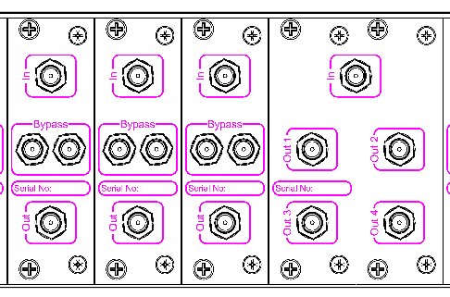

***Options***

4) DC & 10MHz pass-through

5) Fail safe by-pass switching

5b) Fail safe by-pass attenuator links for option 5

6a) 15dB nominal MVG00x gain (at minimum attenuation)

6b) 27dB nominal MVG00x gain (at minimum attenuation)

7a) 30dB nominal MFG00x gain

7b) 40dB nominal MFG00x gain

15) 5dB passive, fixed, slope compensation (L-Band only)

15b) Active, user settable, slope compensation (L-Band only), including variable gain facility

Notes: The addition of options can modify the typical specification, for details please consult the factory

***Rear Panel View*** *(shown with 10 channels fitted)*

VGU010 chassis v1